**Coursera Capstone - Where to open a hotel in London**

**Introduction**

London is the capital of the United Kingdom, and attracts 30 million visitors every year. Therefore, there is a huge hospitality industry in London.

Imagine that you are an entrepreneur who owns a chain of upmarket hotels. You currently do not have a hotel in London, and you are trying to figure out the best place in London to open a hotel. We will use machine learning and data science techniques to solve this problem.

**Data**

As mentioned above, we wish to consider real estate price and proximity to nearby amenities

From the web I found data regarding the average house price in each borough of London, which I will use as a proxy for the real estate price. I read this data into a CSV file called, which can be imported in the notebook.

I will use the Foursquare API to gather data regarding proximity to tourist sites and competitor hotels.

**Price Data of the Boroughs**

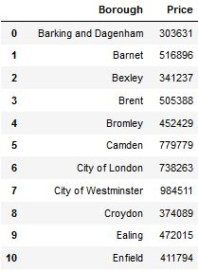

**Map Generated using Folium showing the boroughs of London**

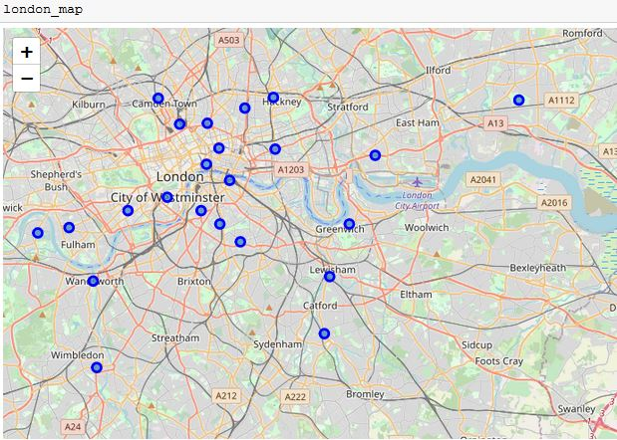

**Using Foursquare API to generate info about nearby amenities in each area**

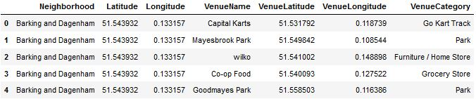

**Observations**

The overwhelming majority of the tourist sites in London are concentrated near 'the square mile'. Therefore, despite this area of London being relatively expensive, I would recommend building the new hotel in that area.